Dome Proposal

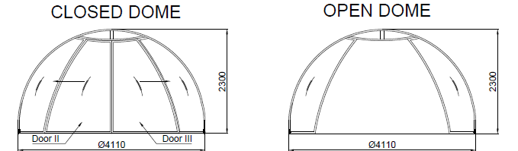
Dear Mr.Ajay Khanna
The basic structure of the DOME consists specially extruded of aluminium profiles with an applied colour surface finish as per the RAL colour. The sheeting come in transparent compact polycarbonate, embossed polycarbonate or in tinted polycarbonate which afford more privacy. It is positioned on a circular guide rail and can be easily assembled when anchored to such solid foundation material as concrete or ceramic block paving.
Proposal
Sales Person: - Pradip Yejare
Client Name: -
Project Name: - Dome
Project Location: -
Date: - 18-12-2019
Quotation No: -

Technical Specification-
- Polycarbonate Israel make Compact/Embossed 3 mm thick
- Transparent with UV protection, thickness 3mm
- Embossed with UV protection, thickness 3mm
- Smoked with UV protection, thickness 3mm
- Profile- Powder Coated AL Frame (As per RAL Colour)
- Guide- Anodized AL Circular Guide Rail
- Height of enclosure: 2.30 m
- Diameter: 4.0 m- 4.11 m
- Weight: 230 kg
- Double door width: 2.4 m approx.

Warranty
- 10 years for Polycarbonate Sheet.
- 5 years for Powder Coated Aluminium Profile.
- 1 Year from the date of supply.

General condition-
- Installation will start after receiving of site Readiness Photographs or written Email Communication
- We will mobilize the installation Team in 3-4 Working days, after receipt of site Readiness Confirmation
- For any reason if we need to stop our installation and demobilize Team without Completing the work, then extra cost will be applicable for remobilizing the team.

These items are not included in the offer
- Secured and fully Covered Store area to keep the material
- Scaffolding/Hydra/Carne/Forklift etc. - Required for installation at site
- Electrical Supply on the Single Phase/ three phase point at different places
- Any civil/masonry/ structural work required
- In case of any changes in layout as per site requirements after the shipment of material, the additional quantities and the wastage

Terms and Conditions
- Price - EX Works Pune
- Delivery – weeks from date of receipt of Confirmed Purchase order, Advance Payment and Drawing approval.
- Payment – 80% Advance along with Confirmed Purchase order and Balance before dispatch.
- Validity – Validity of offer is 15 days from the date of quotation.

